Homepage name: EAT a LOT

1.coffee

2.cafe

3.cakes and ice.

1.coffee and More

By two coffee-[**Address**](https://www.google.co.in/search?espv=2&biw=1024&bih=638&q=by+two+coffee+address&stick=H4sIAAAAAAAAAOPgE-LRT9c3NDIprjAwNjXVks1OttLPyU9OLMnMz4MzrBJTUopSi4sBIpT7ri8AAAA&sa=X&ved=0ahUKEwjb7bDi0KbSAhUGUZQKHSn1BTkQ6BMIezAP)**:**22/1, Police Station Rd, Basavanagudi, Bengaluru, Karnataka 560004

**Order:** [Eatalot](https://www.swiggy.com/bangalore/by-2-coffee-basavanagudi?utm_source=google&utm_medium=place_action)

[**Hours**](https://www.google.co.in/search?espv=2&biw=1024&bih=638&q=by+two+coffee+hours&stick=H4sIAAAAAAAAAOPgE-LRT9c3NDIprjAwNjXVks5OttLPyU9OLMnMz4MzrDLyS4uKAc_6PcItAAAA&sa=X&ved=0ahUKEwjb7bDi0KbSAhUGUZQKHSn1BTkQ6BMIgAEwEQ)**:**

|  |  |  |
| --- | --- | --- |
| **Thursday** | | **7AM–12PM, 4–9:30PM** |
| Friday | | 7AM–12PM, 4–9:30PM |
| Saturday | | 7AM–12PM, 4–9:30PM |
| Sunday | | 7AM–12PM, 4–9:30PM |
| Monday | | Closed |
| Tuesday | | 7AM–12PM, 4–9:30PM |
| Wednesday | | 7AM–12PM, 4–9:30PM |
|  |  |

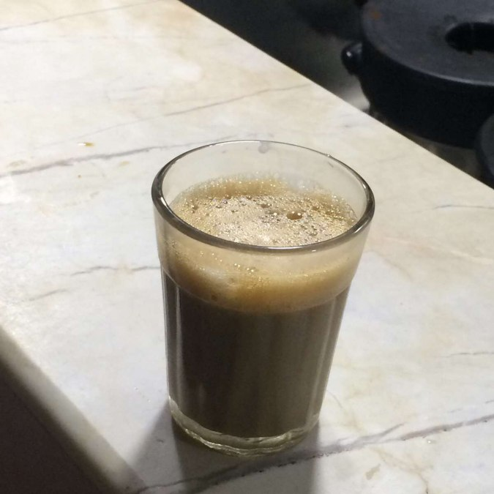

2.vidyarthi bhavan-Enduring restaurant whipping up vegetarian south Indian dishes in easygoing surroundings.

[**Address**](https://www.google.co.in/search?sa=X&espv=2&biw=1024&bih=589&q=vidyarthi+bhavan+address&stick=H4sIAAAAAAAAAOPgE-LSz9U3yMgoyqjK1ZLNTrbSz8lPTizJzM-DM6wSU1KKUouLASaBjAItAAAA&ved=0ahUKEwjWhtne0qbSAhXHFpQKHfW4A1oQ6BMImgEwFA)**:**32, Gandhi Bazaar Main Rd, Gandhi Bazaar, Basavanagudi, Bengaluru, Karnataka 560004

[**Hours**](https://www.google.co.in/search?sa=X&espv=2&biw=1024&bih=589&q=vidyarthi+bhavan+hours&stick=H4sIAAAAAAAAAOPgE-LSz9U3yMgoyqjK1ZLOTrbSz8lPTizJzM-DM6wy8kuLigF_XcpPKwAAAA&ved=0ahUKEwjWhtne0qbSAhXHFpQKHfW4A1oQ6BMInQEwFQ)**:**

|  |  |
| --- | --- |
| **Thursday** | **6:30–11:30AM, 2–8PM** |
| Friday | **6:30–11:30AM, 2–8PM** |
| |  |  | | --- | --- | | Saturday | 6:30AM–12PM, 2:30–8PM | | Sunday | 6:30AM–12PM, 2:30–8PM | | Monday | 6:30–11:30AM, 2–8PM | | Tuesday | 6:30–11:30AM, 2–8PM | | Wednesday | 6:30–11:30AM, 2–8PM |   [**Phone**](https://www.google.co.in/search?sa=X&espv=2&biw=1024&bih=589&q=vidyarthi+bhavan+phone&stick=H4sIAAAAAAAAAOPgE-LSz9U3yMgoyqjK1dLPTrbST87PyUlNLsnMz9PPzssvz0lNSU-NL0jMS80p1s9ILI4vyMjPS7UCkwDvQAjePwAAAA&ved=0ahUKEwjWhtne0qbSAhXHFpQKHfW4A1oQ6BMIogEwFg)**:**080 2667 7588  **Order:** [Eatalot](https://www.swiggy.com/bangalore/vidhyarthi-bhavan-basavanagudi?utm_source=google&utm_medium=place_action)  **C:\Users\User\Desktop\images.jpg** |  |

3.Brahmins coffee bar-Simple, popular joint doling out idli, vada & other breakfast bites, along with coffee.

[**Address**](https://www.google.co.in/search?sa=X&espv=2&biw=1024&bih=589&q=brahmin%27s+coffee+bar+address&stick=H4sIAAAAAAAAAOPgE-LWT9c3LEnLNipPz9WSzU620s_JT04syczPgzOsElNSilKLiwHbjDSVLgAAAA&ved=0ahUKEwjc2Z2a1KbSAhVBEpQKHfb8BpAQ6BMIjAEwEA)**:**Near Shankar Mutt, Ranga Rao Rd, Shankarapura, Bengaluru, Karnataka 560004

[**Hours**](https://www.google.co.in/search?sa=X&espv=2&biw=1024&bih=589&q=brahmin%27s+coffee+bar+hours&stick=H4sIAAAAAAAAAOPgE-LWT9c3LEnLNipPz9WSzk620s_JT04syczPgzOsMvJLi4oBbqSfKywAAAA&ved=0ahUKEwjc2Z2a1KbSAhVBEpQKHfb8BpAQ6BMIjwEwEQ)**:**

|  |  |  |
| --- | --- | --- |
| **Thursday** | | **6–11AM, 4–6:30PM** |
| Friday | | 6–11AM, 4–6:30PM |
| Saturday | 6–11AM, 4–6:30PM |
| Sunday | Closed |
| Monday | 6–11AM, 4–6:30PM |
| Tuesday | 6–11AM, 4–6:30PM |
| Wednesday | 6–11AM, 4–6:30PM |

[**Phone**](https://www.google.co.in/search?sa=X&espv=2&biw=1024&bih=589&q=brahmin%27s+coffee+bar+phone&stick=H4sIAAAAAAAAAOPgE-LWT9c3LEnLNipPz9XSz0620k_Oz8lJTS7JzM_Tz87LL89JTUlPjS9IzEvNKdbPSCyOL8jIz0u1ApMAaQkMF0AAAAA&ved=0ahUKEwjc2Z2a1KbSAhVBEpQKHfb8BpAQ6BMIlAEwEg)**:**087226 64284

Order online-eatalot

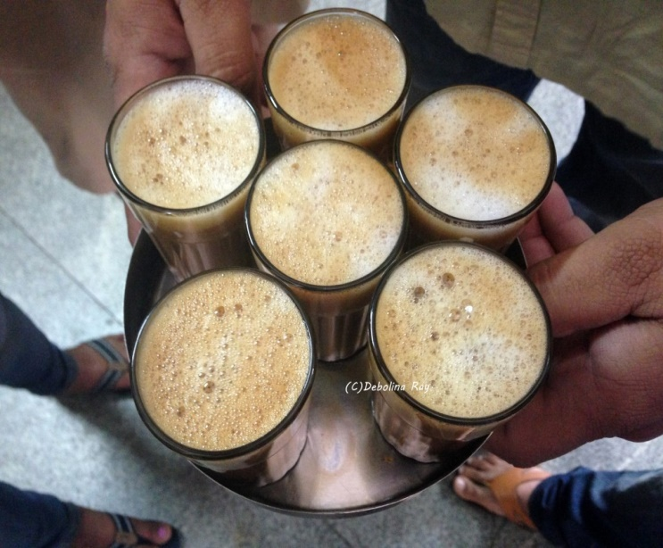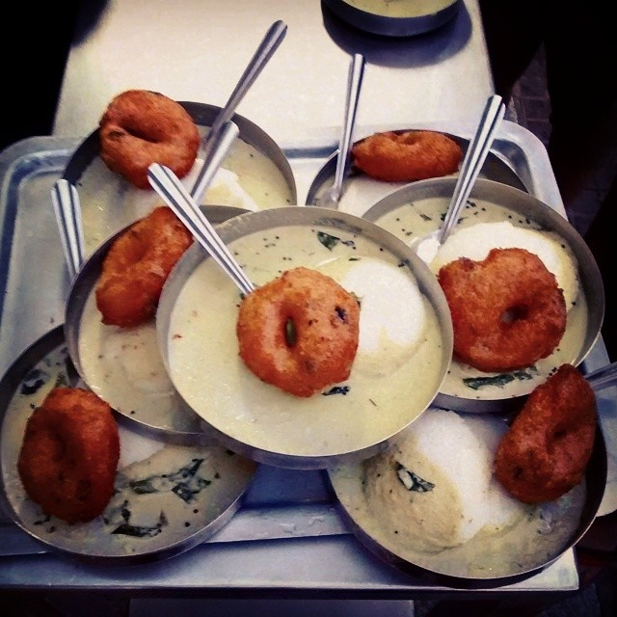

4.South kitchen-[**Address**](https://www.google.co.in/search?espv=2&biw=1024&bih=589&q=south+kitchen+basavanagudi+address&stick=H4sIAAAAAAAAAOPgE-LVT9c3NEwyK6pMMiw31JLNTrbSz8lPTizJzM-DM6wSU1KKUouLAbN2QOAwAAAA&sa=X&sqi=2&ved=0ahUKEwiqqeef1qbSAhXFKZQKHQHMAYwQ6BMIkQEwDw)**:**Near Katte Balaga, 1st Main Road, Subbarama Chetty Rd, NR Colony, Basavanagudi, Bengaluru, Karnataka 560004

[**Phone**](https://www.google.co.in/search?espv=2&biw=1024&bih=589&q=south+kitchen+basavanagudi+phone&stick=H4sIAAAAAAAAAOPgE-LVT9c3NEwyK6pMMiw31NLPTrbST87PyUlNLsnMz9PPzssvz0lNSU-NL0jMS80p1s9ILI4vyMjPS7UCkwBOLg41QgAAAA&sa=X&sqi=2&ved=0ahUKEwiqqeef1qbSAhXFKZQKHQHMAYwQ6BMIlAEwEA)**:**098809 80009

[**Hours**](https://www.google.co.in/search?espv=2&biw=1024&bih=589&q=south+kitchen+basavanagudi+hours&stick=H4sIAAAAAAAAAOPgE-LVT9c3NEwyK6pMMiw31JLOTrbSz8lPTizJzM-DM6wy8kuLigH8DplzLgAAAA&sa=X&sqi=2&ved=0ahUKEwiqqeef1qbSAhXFKZQKHQHMAYwQ6BMImAEwEQ)**:**

|  |  |
| --- | --- |
| **Thursday** | **7AM–12PM, 4–9PM** |
| Friday | 7AM–12PM, 4–9PM |
| Saturday | 7AM–12PM, 4–9PM |
| Sunday | 7AM–12PM, 4–9PM |
| Monday | 7AM–12PM, 4–9PM |
| Tuesday | 7AM–12PM, 4–9PM |
| Wednesday | 7AM–12PM, 4–9PM |

Order online-eatalot

5.MTR-[**Address**](https://www.google.co.in/search?sa=X&espv=2&biw=1024&bih=589&q=mtr%40+lalbagh+address&stick=H4sIAAAAAAAAAOPgE-LWT9c3LEmJtzROSteSzU620s_JT04syczPgzOsElNSilKLiwGgC-n8LgAAAA&ved=0ahUKEwiY1OOI2KbSAhVLmpQKHbn4AVoQ6BMIkQEwDw)**:**14, Lal Bagh Main Road, Sampangi Rama Nagar, Bengaluru, Karnataka 560027

[**Phone**](https://www.google.co.in/search?sa=X&espv=2&biw=1024&bih=589&q=mtr%40+lalbagh+phone&stick=H4sIAAAAAAAAAOPgE-LWT9c3LEmJtzROStfSz0620k_Oz8lJTS7JzM_Tz87LL89JTUlPjS9IzEvNKdbPSCyOL8jIz0u1ApMAqWwPEEAAAAA&ved=0ahUKEwiY1OOI2KbSAhVLmpQKHbn4AVoQ6BMIlAEwEA)**:**080 2222 0022

[**Hours**](https://www.google.co.in/search?sa=X&espv=2&biw=1024&bih=589&q=mtr%40+lalbagh+hours&stick=H4sIAAAAAAAAAOPgE-LWT9c3LEmJtzROSteSzk620s_JT04syczPgzOsMvJLi4oBROHT1SwAAAA&ved=0ahUKEwiY1OOI2KbSAhVLmpQKHbn4AVoQ6BMImAEwEQ)**:**

|  |  |
| --- | --- |
| **Thursday** | **6:30–11AM, 12:30–8:30PM** |
| Friday | 6:30–11AM, 12:30–8:30PM |
| Saturday | 6:30–11AM, 12:30–9:30PM |
| Sunday | 6:30–11AM, 12:30–9:30PM |
| Monday | Closed |
| Tuesday | 6:30–11AM, 12:30–8:30PM |
| Wednesday | 6:30–11AM, 12:30–8:30PM |

Order online-eatalot

